L02: Activity Reflection (Learning Journal)
After completing the activity, fill in the table below.
Instructions
- Choose two features from your website
(for example: navbar, grid, card, or any bootstrap feature).
- Copy 3–6 lines of code related to that feature.
- Write 1–2 sentences explaining what the code does.
Feature Used  Navbar / Grid / Card / any bootstrap feature | AI Prompt Used  Write the prompt you used | Code Generated by AI  Screenshot a small section of the code related to the feature | What I Modified  Describe what you changed | What This Code Does  Explain what the code does
Example:  Card | Generate a Bootstrap card with image, product name and price | 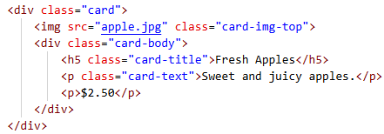 | Changed the product name, description and price | Displays a product card with an image, product description and price
Banner picture on the website | Can you help me generate a banner like picture by using bootstrap | 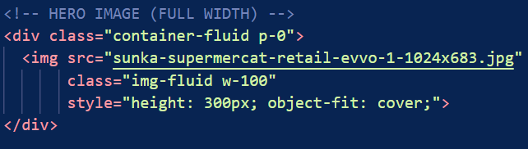 | I added my own picture and also experimented using different height but the measurement given by ai was good | Displays the image as a banner in the homepage of the website
Overlay of apple product description | Can you help me create a bootstrap feature overlay for apple when users click the button view product a pop up overlay will be on the center of the website | 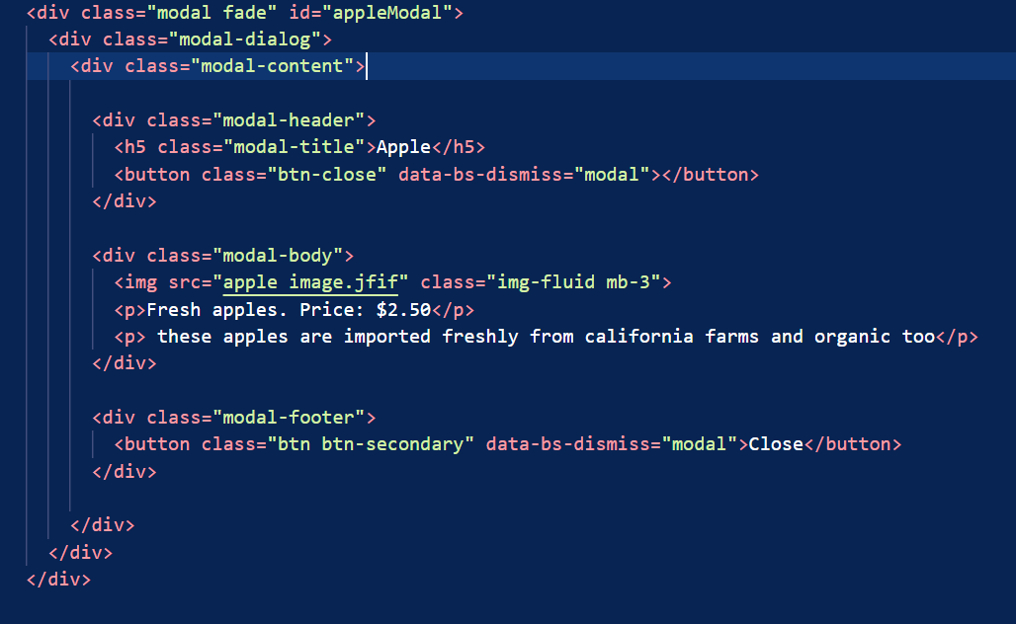 | Added my own apple picture then changed the text to fresh apple and displayed the price  Then wrote a description for it using second <p> | The div class is “modal fade”  The modal dialogue controls position and size of the modal and also automatically canters it on the screen  Then the model content keeps the Header , Body ,Footer all inside the modal this is the box itself  Then for the model there is a header which contains the title and the picture then the body with the descriptions and the price and footer with the back button

